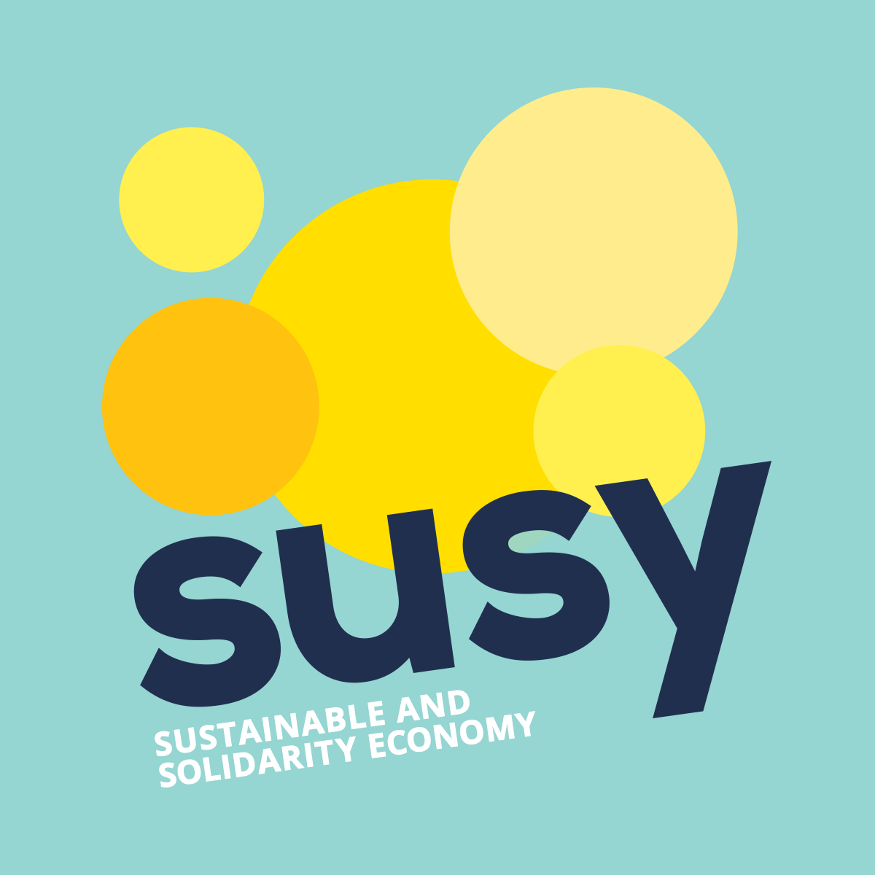
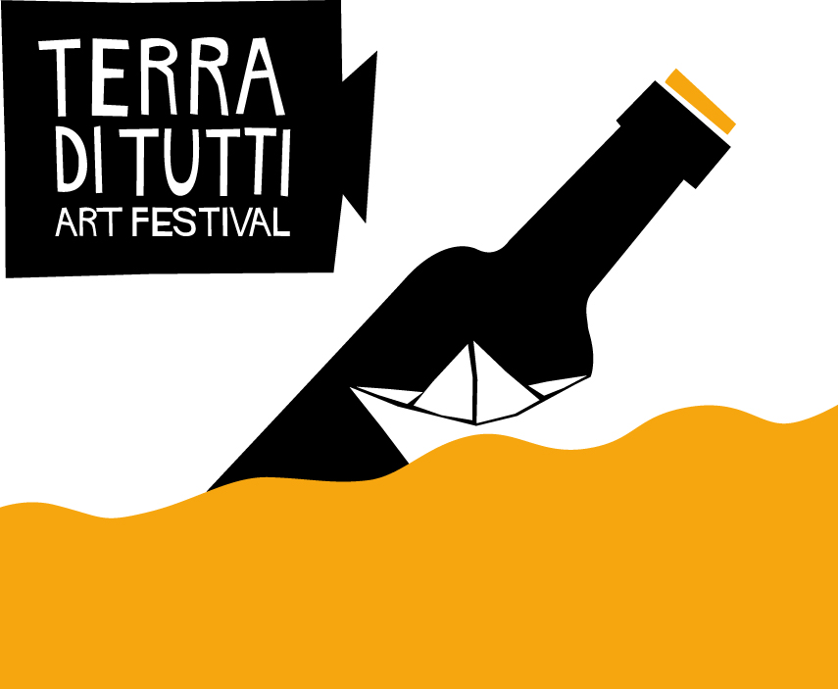

Press release
MAINSTREAMING THE SOCIAL AND SOLIDARITY ECONOMY IN EUROPE
Twenty-six associations from 23 different countries are involved in “SUSY – SUstainable and Solidarity EconomY”, the project co-financed by the European Union to promote alternative production and distribution methods, different consumption and saving models, starting from the best practices of the social and solidarity economy.
Purchasing groups, farmers' markets, ethical finance, bottom up businesses: all of them are examples of the social and solidarity economy, models of production, distribution, consumption and saving based on the principles of equity, sustainability, participation and close link with the territory.
The European project “SUSY - SUstainable and Solidarity EconomY” aims at the promotion of the best practices of the social and solidarity economy realized in Europe and in the world.
Promoted by the non-governmental organization COSPE and Slovak Centre for Communication and Development within a broad international and European partnership, SUSY has a total duration of three years, until January 2018. The main goal of the project is to enhance the competences of local actors that are engaged in the social and solidarity economy, while promoting a new paradigm of economic development in order to fight poverty and diffuse an equitable and sustainable way of living.
Social and solidarity economy is a growing phenomenon, with approximately 6,5% of European workers directly employed in the sector (European Parliament). In 2003, the Brazilian government created the National Secretary of Solidarity economy, while Ecuador and Mexico have adopted a national law on the matter in 2011 and 2012 respectively. In Europe, Spain, Portugal, Belgium and France are also equipped with a national legislation on social and solidarity economy. Luxembourg too has established a specific Ministry for it, while currently in Italy there are 10 regional laws on the subject.
Research, training, information/communication and advocacy are the four vectors in which SUSY will be developed. The research activities involves the mapping of the best practices of social and solidarity economy in 46 territories of the European Union and in 10 countries from the rest of the world (Brazil, Bolivia, India, Israel, Malaysia, Mauritius, Mozambique, Palestine, Tunisia and Uruguay). The best practices will be analyzed and compared in several workshops throughout Europe. The trainings will be conducted in the 46 territories involved in the project.
Several communication and information activities will be realized, from the opening of a website with a map of the most relevant experiences of social and solidarity economy, to the realization of a video-reportage, speaker tours, competitions and film festivals. The European citizenship will also be sensitized through various local events, while the advocacy activities will mainly involve institutional representatives and politicians at the European and local level.
The project “SUSY – SUstainable and Solidarity economY” will be officially presented on Thursday, October 8th in Bologna. The main speaker of the event will be the economist and university professor Paul Singer, the National Secretary of Solidarity Economy under the Ministry of Labour and Employment of the Brazil Government, considered the founding father of the social and solidarity economy. With him there will be Magda de Sousa Almeida, the representative of the union of cooperatives and solidarity enterprises Unisol Brasil, Jason Nardi, the European coordinator of RIPESS (Intercontinental Network for the Promotion of Social and Solidarity Economy), Alberto Veronesi, the president of Arvaia, a cooperative of biological growers of Bologna and Fabio Laurenzi, the president of COSPE.
List of partners:
The project “Susy – Sustainable and solidarity economy” is realized by: COSPE and Fairwatch (Italy), Südwind Agentur (Austria), Inkota (Germany), Deša Dubrovnik (Croatia), Kopin (Malta), Cerai (Spain), Polish Fair Trade Coalition (Poland), Ekumenicka Akademie Praha Europe (Czech Republic), Fair Trade Hellas (Greece), ngo Mondo (Estonia), Balkan Institute for Labour e Social Policy (Bulgaria), Cardet (Cyprus), Pro Ethical Trade Finland (Finland), Resources Humaines sans Frontières (France), The Co-operative College e Think Global (United Kingdom), Cromo Foundation e Foundation for Development of Democratic Rights DemNet (Hungary), Instituto Marquês de Valle Flôr (Portugal), Terra Mileniul III Foundation (Romania), Slovak Centre for Communication e Development (Slovakia), Peace Institute – Institute for Contemporary Social e Political Studies (Slovenia), Action pour le Développement Asbl – Sos Faim (Belgium), Green Liberty (Latvia) and Waterford One World Centre (Ireland).
For more information:
www.solidarityeconomy.eu
Eva Sládková, PR manager SCCD, sladkova@sccd-sk.org, 0903 576 184
COSPE, tel. + 39 051 546600, sito www.cospe.org
Elisa Delvecchio (international project coordinator), e-mail elisa.delvecchio@cospe.org
Samanta Musarò (international project secretary), e-mail samanta.musaro@cospe.org
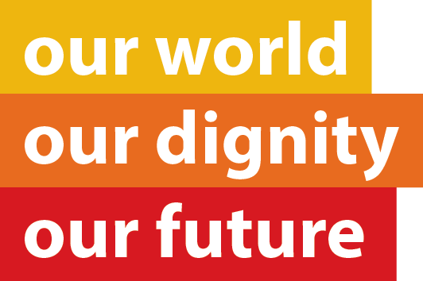
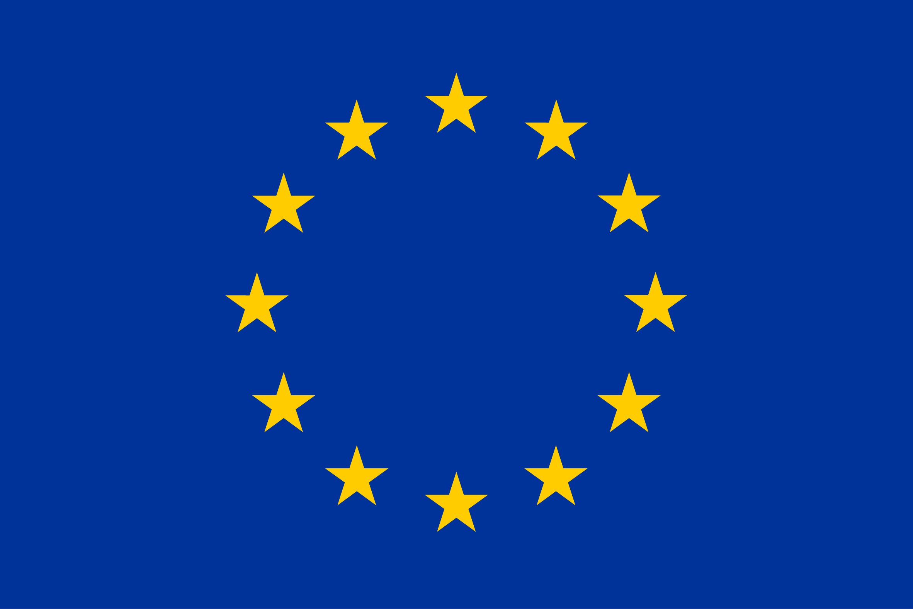
This publication has been produced with the assistance of the European Union. The contents of this publication are the sole responsibility of COSPE and can in no way be taken to reflect the views of the European Union.

